**Table of Contents**

|  |  |
| --- | --- |
| Procter & Gamble - Wikipedia  p&g sALES FORECAST REPORT | Submitted by: Jagannath Kharel |

Section 1: Introduction

Section 2: Literature Review

Section 3: Managerial Overview

Section 4: Application of Forecasting Methods and Results

Section 5: Conclusion and Limitations

Section 6: References

**Section 1 : Introduction**

The company selected for analysis is Procter & Gamble Company (P&G). Its Fiscal year (FY) begins in July and ends next June. The quarterly sales of 9.5 years which comprises of 38 quarters beginning from FY 2014-15 to Q2 of 2023-24 are reported in Million USD. The objective of the study is to forecast 6 quarters i.e. Q3 2023-24 to Q4 2024-25 which can aid P&G in planning time and resources to meet the expected demand. This forecast also helps the other FMCG players to strategize their future course of action to meet the expected demand.

P&G can plan based on these forecasts and carry out required actions in its value chain which is forward and backward integrated. Its trusted supply chain distributors must be alerted to the upcoming demand to avoid delays in raw material supply. On other hand, if the raw materials require time to create, then these forecasts come in hand to estimate the time and number of raw materials which need to be generated.

Going by the words of Al Enns, director of Supply chain strategies, Motts North America, *“If you can get the forecast right, you have the potential to get everything else in the supply chain right”[1]* So we presume the output of this forecast will help P&G in much more than expected.

**Section 2 : Literature Review**

Procter & Gamble Co. (P&G), the largest manufacturer and marketer of fast-moving consumer goods (FMCG) is committed to giving customers all around the world branded consumer packaged goods. Its portfolio includes products catering to health, beauty, home, baby, feminine, family, and personal care segments. These goods are marketed with different brands names a few of them are Oral-B, Pampers, Gillette, Braun, Fusion, Bounty, Head & Shoulders, Tide, Ariel, Olay, and Pantene etc. Within America P&G offers its products under 250 brands.

The story of P&G - Candlemaker William Procter and soap maker James Gamble left England and Ireland, respectively. They began their business in 1837 in Cincinnati. Over the years the business expanded into a multimillion-dollar enterprise. Candles were formerly a mainstay of the company's but with the invention of electric light bulb, Candles appeal decreased which was stopped completely by P&G in the 1920s. One of P&G's mainstay goods is soap. P&G was the first business to run a nationwide direct-to-consumer advertisement (Ivory soap, 1880s).

The main sales channels for the company's products are mass merchandisers, e-commerce, including social commerce channels, grocery stores, membership club stores, drug stores, department stores, distributors, wholesalers, specialty beauty stores (including duty-free shops at airports), high-frequency stores, pharmacies, electronics stores, and professional channels in about 180 countries and territories. Additionally, it sells directly to customers. It operates in almost 70 different nations. Asia-Pacific, Europe, the Middle East, Africa, and the Americas are among its business hubs. The US city of Cincinnati, Ohio, is home to P&G's headquarters.

FMCG industry is the largest industry globally, which essentially meets the needs of customers. As of 2023, the FMCH Industry value in USA is $835.4 billion, which is expected to rose to $902.2 by 2027.[2] Though the future looks lucrative, yet the competitive landscape in that industry is fierce. Meeting the evolving consumer needs while maintaining profits and overcoming supply chain challenges is giving hard time for the players. Many big players like Unilever, Nestle, Kellogg’s, and General Mills, to name a few are competitors for P&G.

SWOT Analysis - P&G principal advantages are its large operational scale, capacity for innovation, and dominant position in the industry; yet its limited liquidity and reliance on a small number of clients continue to be concerns for worry. The introduction of new products, the worldwide market for feminine hygiene products, and the skin care industry are probably going to present growth prospects for the business. However, dangers associated with foreign exchange, fierce rivalry, and stringent restrictions may limit its growth prospects.

**Section 3 : Managerial Overview of Methods to be used.**

Evaluating P&G’s quarterly sales data over a significant 9.5-year period from Fiscal year Q1 2014-15 to Q2 of 2023-24 reveals unique trends, including a steady upward trend in sales and observable seasonality. What we understand about the statistics is further shaped by a recurrent fall in Q3 from January to March.

The Moving Average model, Holts model and Winters model are to understand trend and seasonality. These models provide a detailed projection that makes it possible to anticipate sales patterns and fluctuations within time periods with accuracy.

The choice and suggestion of these advanced forecasting techniques demonstrate a shared practical grasp of the fundamentals of sales and marketing forecasting. The goal of the model’s usage and output is to give P&G an accurate forecast on its future sales. A period of 6 quarters is considered for forecast, however timely changes can be accommodated in the model to account the unpredictable macro and micro economic circumstances and interpret most likely long-term trends.    
   
To begin with we have included only the sales component in future forecasts. However, it is understandable that there are many other factors which determine company sales, given certain limitations, we haven’t accounted for all other parameters like marketing costs etc. However, this study is intended to provide a glimpse of the sales forecast. The application of advanced forecasting methods to the real-world data helps in integrating the theoretical ideas in practice and generate valuable insights which indeed are intended to serve the end user effectively.

**Section 4 : Application of Forecasting Methods and Results**

The data collected for analysis is of P&G for the years 2014 to 2023, which includes 38 quarters data.

**TIME SERIES PLOT**

The time series plot (Plot 1) exhibits the sales pattern over each quarter. The line indicates the rise or fall or stability in the sales of the company. A significant decline in the sales is noticed Q3 2014 to Q3 2016 after which P&G sales exhibited positive trend with slight but not drastic declines in sales. The plot’s Y-axis base bar value began from $16000 and all the points below are slightly lesser than the value.

**Plot 1: Time Series Plot**

Before further proceeding into data analysis, we checked if the data is exhibiting any linear trends. On plotting a scatter plot (Plot 2) it is evident that Quarterly data is not clearly following any linear trend. The R-Square value is very less.

**Plot 2: Scatter Plot**

To visually check the performance of quarters, we created a scatter plot. It is visually evident that sales followed a increasing trend since 2018 yearly, but at quarterly level the trend is non-linear.

From Plot 1 and Plot 2, we inferred that data has a linear as well as nonlinear trend, which can be understood only after running the data through more advanced models.

**AUTOCORRELATION PLOTS**

From the **ACF Plot (Plot 3)**, the Autocorrelations declined gradually. Slow decay in ACF plots is indicating the presence of **trend** in the data. Also, from Plot 1 &2 we observed a sudden decline in the initial quarters and then incremental growth over the next quarters. From these visual observations we assumed that data exhibited “**TREND**”, which is a combination of positive and negative.

Furthermore. From ACF plots, we can see significant correlations at low lags, which theoretically means that data exhibited “**SEASONALITY”** – comparison of sales in a specific quarter related to sales in the same quarter of the previous year(s).

**Plot 3: ACF Plot**

From **PACF plot (Plot 4)**, we found no significant correlations beyond the first few lags. It means, the current value is not directly related to any past values after accounting for the influence of previous lags, potentially indicating a more random process. Sudden drops or spikes indicated more complex patterns requiring further investigation or alternative modeling approaches. Also, the sharp cutoff in PACF plots is an indication of **SEASONAL** patterns in the data.

**Plot 4: PACF Plot**

**EXPONENTIAL SMOOTHING**

Because our data is nonlinear, we have used **centered moving average to measure the TREND** in our analysis. Centered Moving Average is expected to work better for time series exhibiting either linear or non-linear trends. We have tabulated (refer to Table 1) the most important diagnostic parameters to be checked for deciding on the lag value.

**Table 1**

|  |  |  |  |  |  |  |
| --- | --- | --- | --- | --- | --- | --- |
| **TS Model** | **R- Square** | **RMSE** | **MAPE** | **Sig** | **Durbin -Watson** | **VIF** |
| MA2 | 0.955 | 350.482 | 1.448 | 0.312 | 0.171 | 1.0000 |
| **MA3** | **0.947** | **398.254** | **1.683** | **0.007** | **0.126** | 1.0000 |
| MA4 | 0.958 | 313.369 | 1.320 | 0.134 | 0.191 | 1.0000 |
| **PMA2** | **0.940** | **442.29** | **1.795** | **0.040** | **0.344** | 1.0000 |
| PMA3 | 0.967 | 398.254 | 1.683 | 0.007 | 0.252 | 1.0000 |
| PMA4 | 0.957 | 328.701 | 1.375 | 0.654 | 0.168 | 1.0000 |

From the numbers, we found that Moving Average 3 yielded similar results when the data is treated with Prior moving average at lag 3(PMA3). The key metrics of PMA2 are also significant. The values are collected from SPSS Output. So, going by the model significance, we found **MA3** and **PMA2** are ideal for our forecast.

From the Tabe 1 values **low MAPE** value of MA3 over PMA2 indicates that MA3 model is good in **ACCURACY –** which indicates the model accuracy in forecasting**.** The **low RMSE** value of MA3 indicates, the model is good **FIT –** *model works retrospectively***.** So, we use **MA3** in this analysis.

The **Durbin- Watson values** which explain the existence of **positive autocorrelation**. Because we have considered only 1 independent variable in estimating future sales, explains the reason behind positive correlation. The scope of treating it is negative because transforming “Time” variable i.e. Quarters and Years is not possible.

While Omission is as well not possible given the fact that data exhibited seasonality, omission of some quarters data might as well limit our understanding about seasonal patterns. So, we decided to not treat the positive autocorrelation.

**Moving Average Plots**

We plotted MA series (***Plot 5****)* to visually study the data patterns. Of all the Moving average estimates, MA4 exhibited more smoothening. However, the model statistics we inferred that MA3 model can explain the data patterns by 95% and low MAPE and RMSE values defined that the model accuracy is good and error percentages in forecasting is very low. It is further concluded by the significance value, which is 0.007, means that the model results are not predicted by chance, but more likely based on hidden patterns in the previous data.

**Plot 5: Moving Average Plot**

**HOLD OUT DATA**

To validate the model performance, we maintained a “hold out” period of 4 quarters to evaluate our model forecast accuracy. Our hold our period was Q3 of fiscal year 2022-23 to Q2 of fiscal year 2023-24.

Using the Hold out data, we evaluated our MA3 model and PMA2 Models forecasts. From ***Plot 6*** below, we observed that MA3 model forecasts were closer to actual forecast data. From model summary also the 3 metrics (r-Square, MAPE, Significance) of MA3 are better than that of PMA2. So once again we conclude that MA3 model will accurately forecast. The base line on Y-axis in the plots began from 12000 and 14000. The axis points are taken by SPSS software.

**Plot 6: Moving Average Plots**

**Holts Linear Model**

Because our data (P&G) exhibited upward and downward trend, which was inferred from the time series plot, we decided to use Holts’ model to understand more about the trend (data exhibited both downward and upwards trends).

As we know that Holts considers only trends in data but not seasonality, it is expected that the Holts model exhibits an upwards trend. However, on comparing the key metric values, Holts linear models doesn’t explain any better than MA3. The comparison metrics are tabulated in *Table 2.*

**Table 2**

|  |  |  |
| --- | --- | --- |
| **Metrics** | **Holts Linear Model** | **MA3** |
| Significance | <0.001 | 0.007 |
| R-Square | 0.782 | 0.975 |
| RMSE | 867.210 | 270.598 |
| MAPE | 4.039 | 1.168 |

To enable visual aid, we have included Holts linear graph (Plot 7a) and MA3 plot (Plot 7b) below. The base line on Y-axis began from 14000. The axis points are taken by SPSS software.

**Plot 7a: Holts linear model graph.**

**Plot 7b: MA3 Plot**

**Winters Exponential Smoothing**

From the Time series graph, we noticed recurrence of spike and fall at Q2 and Q3 quarters consistently. So, we inferred that data exhibits a seasonal pattern with sales reaching a peak in Q2 followed by a sharp decline in Q3. So, to explain the **TREND and SEASONALITY** of the data we used Winters exponential smoothing model. Though the model at 95% significance is not good, yet other metrics are better than that of Holts Linear model. Key metrics of all the 3 models are tabulated in ***Table 3.***

**Table 3: Diagnostic metrics**

|  |  |  |  |
| --- | --- | --- | --- |
| **Metrics** | **Winters Multiplicative Model** | **Holts Linear Model** | **MA3** |
| Significance | 0.131 | <0.001 | 0.007 |
| R-Square | 0.931 | 0.782 | 0.975 |
| RMSE (Fit) | 496.934 | 867.210 | 270.598 |
| MAPE (Accuracy) | 1.985 | 4.039 | 1.168 |

We plotted sales using the Winters multiplicative model *(Plot 8)* and observed that the forecast is much aligned with the past data points. The base line on Y-axis began from 14000. The axis points are taken by SPSS software.

**Plot 8: Winters Multiplicative forecast plot**

**Time Series Decomposition**

Because our data exhibit multiple patterns like trend and seasonality, we would like to further analyze the data to understand the underlying patterns using Time-series decomposition. Where we split a time series into components which represent the underlying pattern.

**Seasonal Decomposition**

To check the seasonality component of the sales data from the seasonal factors, it is evident that magnitude and impact of seasonal factors on the data is quite significant. So, taking the seasonality into consideration, we decided to decompose our data further. Seasonal index table for 4 quarters is provided in **table 4**.

**Table 4: Seasonal index table**

|  |  |
| --- | --- |
| **Period** | **Seasonal Factor (%)** |
| 1 | 101.5 |
| 2 | 103.7 |
| 3 | 96.6 |
| 4 | 98.2 |

So, we decomposed sales data at **d=1** in SPSS. From the generated trend, seasonal, and error components, we generated plots for actual sales and seasonally adjusted sales data ***(Refer to plot 9)***. From the plot the seasonally adjusted sales data graph followed the sales data closely. Therefore, we chose to use d=1 for our subsequent analysis.

**Plot 9: Seasonally adjusted sales and actual sales graph**

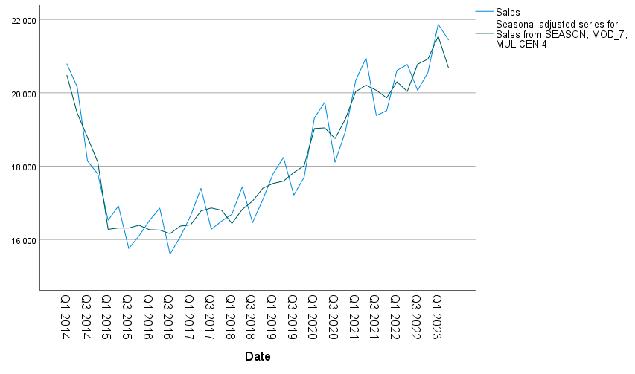

In this step we would like to check Autocorrelation plots of seasonally adjusted sales data. From the **ACF Plot** *(Plot - 10)*, we observed a gradual decline without significant peaks, it suggests the presence of a trend in the data. The gradual decay also suggests for a Moving average (MA) model. From the plot, we also observed the lags become non-significant after the 7th lag. Because the plot displayed a gradual decline, we decided to check different values of **q =1, 2,3,4**.

From **PACF** we observed 1 sudden dip after the first lag. So, for the Auto Regressive component, we choose **p = 1.** In both ACF and PACF plots the base line on Y-axis began from 16000. All the points below are little less than 16000. The axis points are taken by SPSS software.

**Plot** **10**- **Autocorrelation plots of Seasonally adjusted sales data**.

|  |  |
| --- | --- |
|  |  |

From the data decomposition, ACF and PACF plot, we understood that data can be better analyzed further if we perform **ARIMA model**. Multiple combinations p,d,q are used to perform ARIMA models. The model parameters are tabulated ***(Refer to Table - 5)*** for comparison purposes. Residual autocorrelation plots *(Plot 11)* are also generated for every model to check upon model significance using residuals.

**Table 5*:* Diagnostic Parameters**

|  |  |  |  |  |  |
| --- | --- | --- | --- | --- | --- |
| **ARIMA (p,d,q)** | **0,1,1** | **1,1,1** | **1,1,2** | **1,1,3** | **2,1,2** |
| Normal BIC | 12.728 | 12.774 | 12.898 | 13.024 | 13.008 |
| R-square | 0.906 | 0.914 | 0.914 | 0.914 | 0.915 |
| MAPE | 1.945 | 2.080 | 2.093 | 2.087 | 2.105 |
| RMSE | 526.613 | 513.54 | 519.93 | 527.47 | 512.313 |
| Ljung-Box Sig | 0.949 | 0.964 | 0.953 | 0.894 | 0.946 |

**Plot 11 - Residual Autocorrelation plots of Sales and seasonally adjusted sales data**

From the model metrics, we deduced that **ARIMA (0,1,1)** will be a good fit model given the **LOW** **BIC and MAPE values**. Because Low BIC means the model provides the **best balance** between model fit and complexity. Low MAPE means the model exhibited **a high level of accuracy** in predicting future values. Because our data is time series data, RMSE and R-Square diagnostics better explain regression data. Along with LOW BIC and MAPE, the residuals correlation plots showed that residuals close to mean 0. So, we choose to use ARIMA (0,1,1) for predicting P&G’s next 8 quarters starting from Q3 2023 to Q2 2025.

**Forecasts**

Used ARIMA (0,1,1) to predict sales of P&G for the quarters Q3 2023 to Q2 2025. The forecasted values are tabulated in Table 6. We used seasonally adjusted series to predict the forecasts using ARIM (0,1,1). The generated values are multiplied by the seasonal index factors to address the data seasonality component. Thus, the re-seasonalized sales values are the forecasted values for the next 8 quarters.

**Table 6 – Forecasted Sales**

|  |  |
| --- | --- |
| **Quarters** | **Forecasted Sales** |
| Q3- 2023 | 20601 |
| Q4- 2023 | 20844 |
| Q1- 2024 | 20968 |
| Q2- 2024 | 20353 |
| Q3- 2024 | 20585 |
| Q4- 2024 | 20827 |
| Q1- 2025 | 20951 |
| Q2- 2025 | 20337 |

Finaly, we wanted to visually confirm if the actual sales and forecasted sales are following a similar trend and if the seasonality is reflected **(Plot 12**). So, we plotted actual sales, seasonally adjusted sales, and forecasted sales. Because the graphs clearly follow similar patter, it is again confirmed that ARIMA (0,1,1) forecasts are appropriate and is advised to consider.

**Plot 12**: Forecasts of Actual sales and Predicted Sales

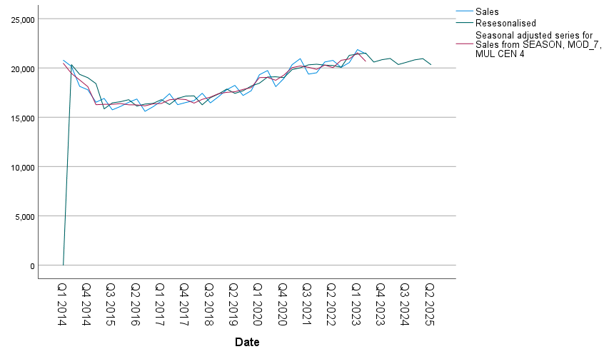

**Model Comparison**

To compare the diagnostic metrics of all the models which we used to analyze data are tabulated for better inference (Table 7). The forecasted values are also tabulated in Table 8.

**Table 7:** Model Metric Comparisons

|  |  |  |  |
| --- | --- | --- | --- |
| **Metrics** | **Winters Multiplicative Model** | **ARIMA (0,1,1)** | **Holts Linear Model** |
| ***R-Square*** | 0.931 | 0.906 | 0.782 |
| ***RMSE (Fit)*** | 496.934 | 526.613 | 867.210 |
| ***MAPE (Accuracy)*** | 1.985 | 1.945 | 4.039 |
| ***BIC*** | 12.702 | 12.726 |  |
| ***Ljung- Box Significance*** | 0.131 | 0.949 | <0.001 |

**Table 8:** Forecasted Values

|  |  |  |  |  |  |  |  |  |  |  |  |  |  |  |  |  |  |  |  |  |  |  |  |  |  |  |  |  |
| --- | --- | --- | --- | --- | --- | --- | --- | --- | --- | --- | --- | --- | --- | --- | --- | --- | --- | --- | --- | --- | --- | --- | --- | --- | --- | --- | --- | --- |
| |  |  |  | | --- | --- | --- | | **Quarters** | **Winters Multiplicative Model** | **ARIMA (0,1,1)** | | Q3- 2023 | 20096 | 20601 | | Q4- 2023 | 20519 | 20844 | | Q1- 2024 | 21553 | 20968 | | Q2- 2024 | 21538 | 20353 | | Q3- 2024 | 20187 | 20585 | | Q4- 2024 | 20611 | 20827 | | Q1- 2025 | 21650 | 20951 | | Q2- 2025 | 21635 | 20337 | |  |

**Which is the best model for P&G’s forecast?**

From the diagnostic metrics, it appeared that Winters Multiplicative model appeared to be more appropriate for forecasts given the low BIC and MAPE values. Both values explain the models **best fit** which can explain all the underlying complexities as well as **accuracy** in forecasting the future values respectively.

**Section 5 : Limitations**

* The first limitation we came across is the limited availability of data. If more data is available or collected a much more comprehensive analysis and forecast can be done.
* The second limitation is the availability of P&G’s previous strategic actions to address the sales decline in Q3 and Q4. If this information is available, then we will be able to analyze the drawbacks if any.

**Conclusion**:

Forecasts made using Winter’s Multiplicative model or ARIMA (0,1,1) are accounting P&G sales trend and seasonality patterns completely. So, it will be beneficial for P&G to consider these forecasts and can make necessary strategic changes to address the seasonality issues to ensure sales growth, particularly in Q3. Furthermore, to reiterate the accuracy of our forecast, we checked the actual sales posted by P&G for the period Q3 2023. The values are tabulated in Table 9. **Our Winters multiplicative forecast is very close to actual sales**.

**Table 9: Forecasts vs actual sales**

|  |  |  |  |
| --- | --- | --- | --- |
| **Quarters** | **Winters Multiplicative Model** | **ARIMA (0,1,1)** | **Actual sales posted** |
| Q3- 2023 | 20096 | 20601 | ***$ 20195*** |

**Section 6 : References**:

1. The Procter & Gamble Co | UConnect. (n.d.). <https://cdn.uconnectlabs.com/wp-content/uploads/sites/82/2020/02/Procter_Gamble.pdf>
2. <https://www.designrush.com/best-designs/logo/procter-gamble>
3. Scribd. (n.d.). Procter & Gamble: Company’s profile. Scribd. <https://www.scribd.com/doc/185079522/P-n-G>
4. CNBC. (n.d.). Check out Procter & Gamble’s stock price (PG) in Real time. CNBC. <https://www.cnbc.com/quotes/PG>
5. Plc, G. (n.d.). The Procter & Gamble Co - company profile. <https://www.globaldata.com/company-profile/the-procter-gamble-co/swot-analysis/>
6. Textbook: J. Holton Wilson and Barry Keating. Business Forecasting, Sixth Edition (McGraw-Hill/Irwin, 2009) ISBN 978-0073373645

1. Textbook: J. Holton Wilson and Barry Keating. Business Forecasting, Sixth Edition (McGraw-Hill/Irwin, 2009) ISBN 978-0073373645
2. www.alliedmarketresearch.com/fmcg-market